**Questions List:**

**\* Physics Grade 7-Motion and Time**

1.Select the correct definition of speed from the options below:

(a). Displacement of a body in unit time

(b). Position of a body at any given instant of time

(c). Change in position of a body with time

(d).

2.A characteristic property of speed and velocity is:

(a). Speed is vector, velocity is scalar

(b). Both speed and velocity are scalars

(c). Both speed and velocity are vectors

(d). Speed is scalar, velocity is vector

3.What is time period for an oscillating pendulum?

(a). Time taken by the pendulum to complete one oscillation

(b). Number of oscillations in unit time

(c). Time taken by the bob of the pendulum to go from mean to extreme position

(d). Time taken by the oscillating pendulum to come to rest

4.A quantity that always remains constant for a pendulum of a given length is:

(a). Frequency

(b). Time period

(c). Wavelength

(d). Number of oscillations

5.Speedometer and Odometer are devices used for measuring:

(a). Speed and Time Taken

(b). Speed and number of wheel revolutions

(c). Speed and Tyre pressure

(d). Speed and distance travelled

6.For a distance versus time graph, a straight line parallel to time(X) axis means:

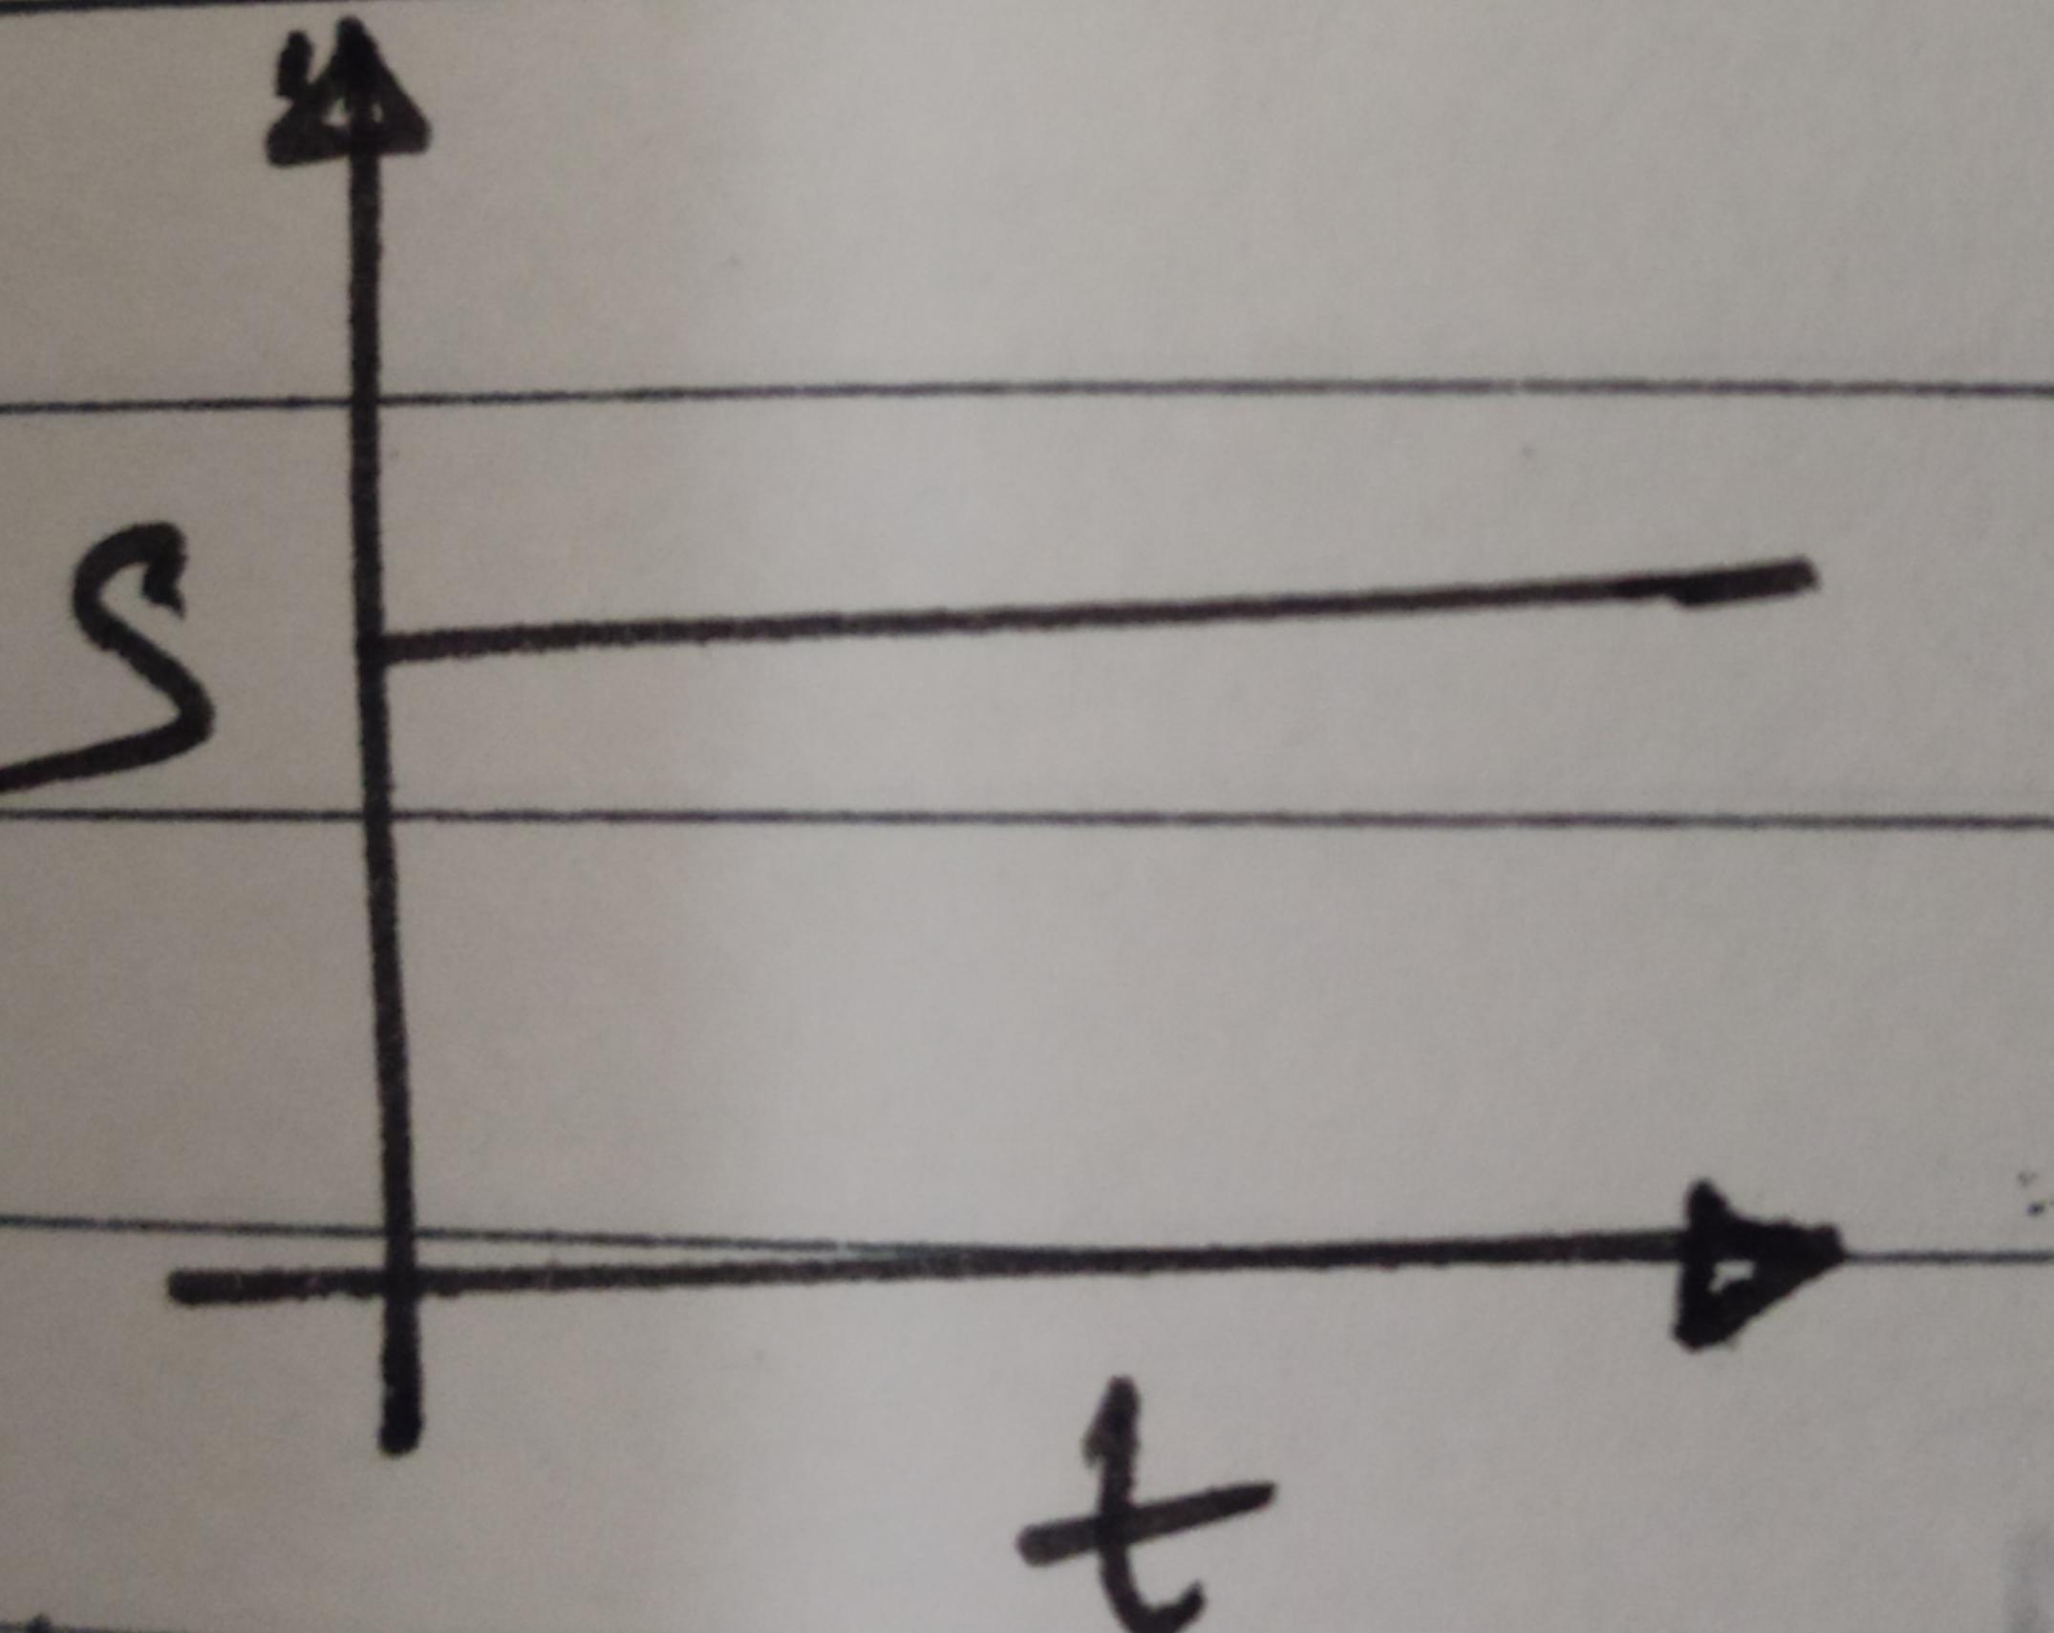

(a). A body at rest

(b). A body travelling at constant speed

(c). A body with constant acceleration

(d). A body in uniform circular motion

7.A typical velocity versus time plot is given below for a body. What do regions A,B,C and D represent?

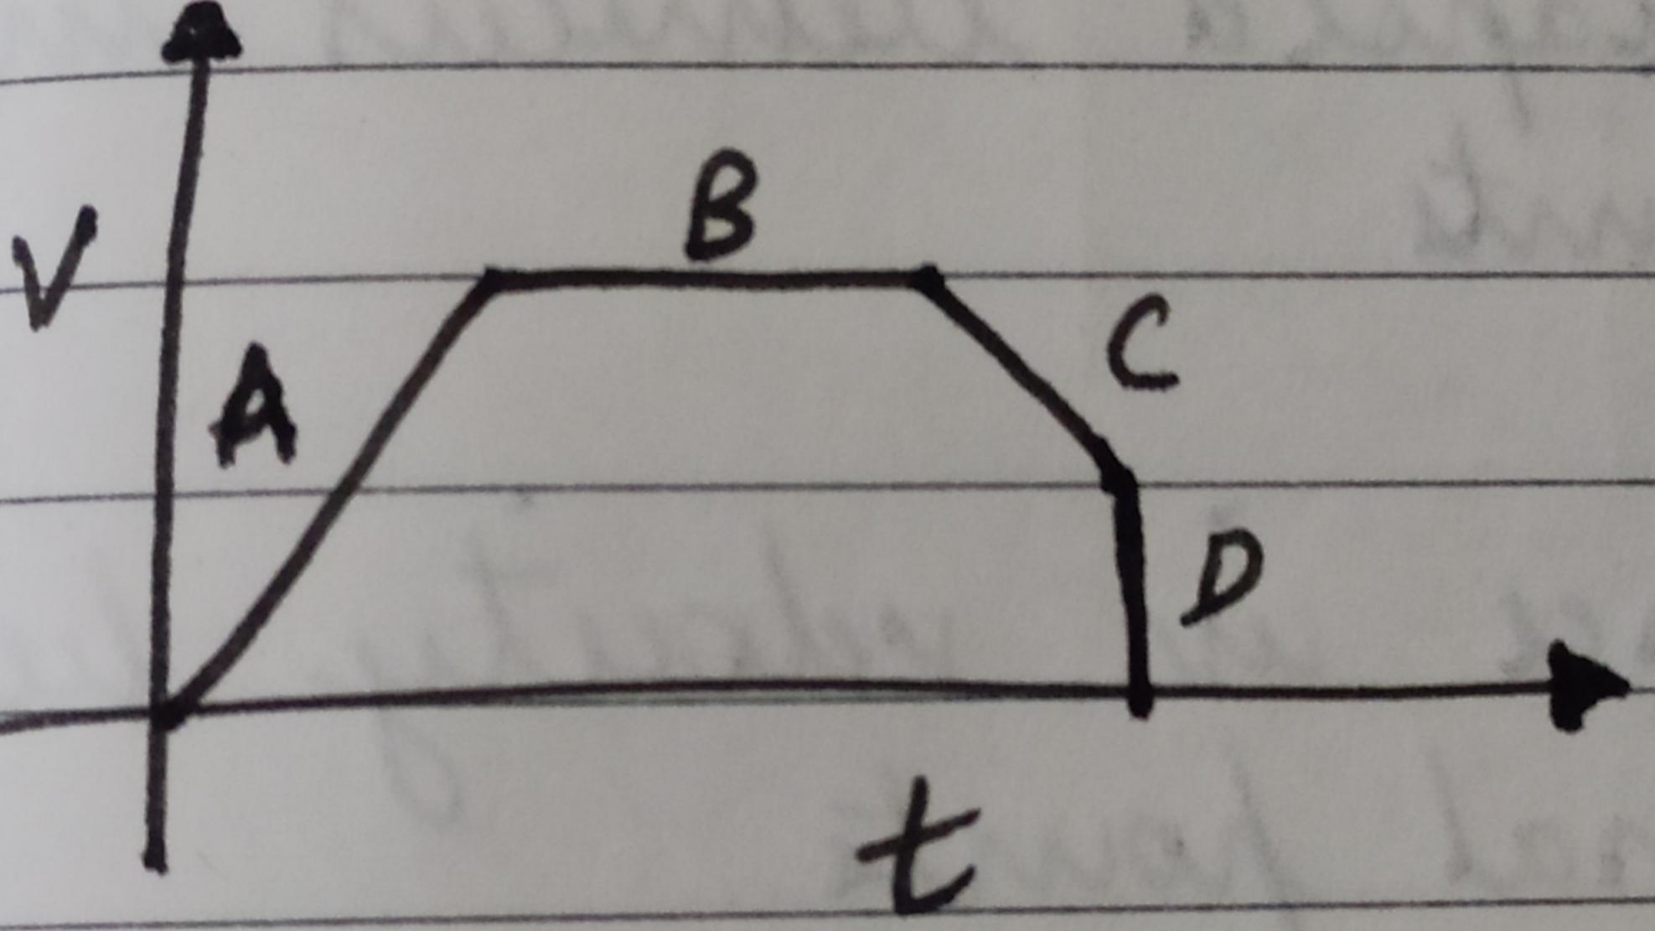

(a).

|  |  |
| --- | --- |
| A 🡪 | acceleration of body |
| B 🡪 | constant velocity |
| C 🡪 | deceleration |
| D 🡪 | infinite acceleration |

(b).

|  |  |
| --- | --- |
| A 🡪 | deceleration |
| B 🡪 | constant acceleration |
| C 🡪 | acceleration |
| D 🡪 | constant velocity |

c).

|  |  |
| --- | --- |
| A 🡪 | acceleration |
| B 🡪 | constant velocity |
| C 🡪 | deceleration |
| D 🡪 | zero acceleration |

(d). None of the above

8.The area under the curve of a velocity-time graph represents:

(a). Acceleration

(b). Time elapsed between initial and final points

(c). Difference in velocity between initial and final points

(d). Distance

9.Deceleration means:

(a). Increase in velocity

(b). Uniform velocity

(c). negative acceleration

(d). Constant acceleration

10.Frequency is defined by the formula:

(a).

(b).

(c).

(d).

11.Which of the following instruments can be used to measure time in sport events?

(a). Hour glass

(b). Wristwatch

(c). Atomic clock

(d). Stopwatch

12.A bus travelling at an avg. speed of 60 kmph takes 3 hours to reach city B from city A. How far is B from A?

(a). 120 km

(b). 20 km

(c). 180 km

(d). None of the above

13.This graph represents:

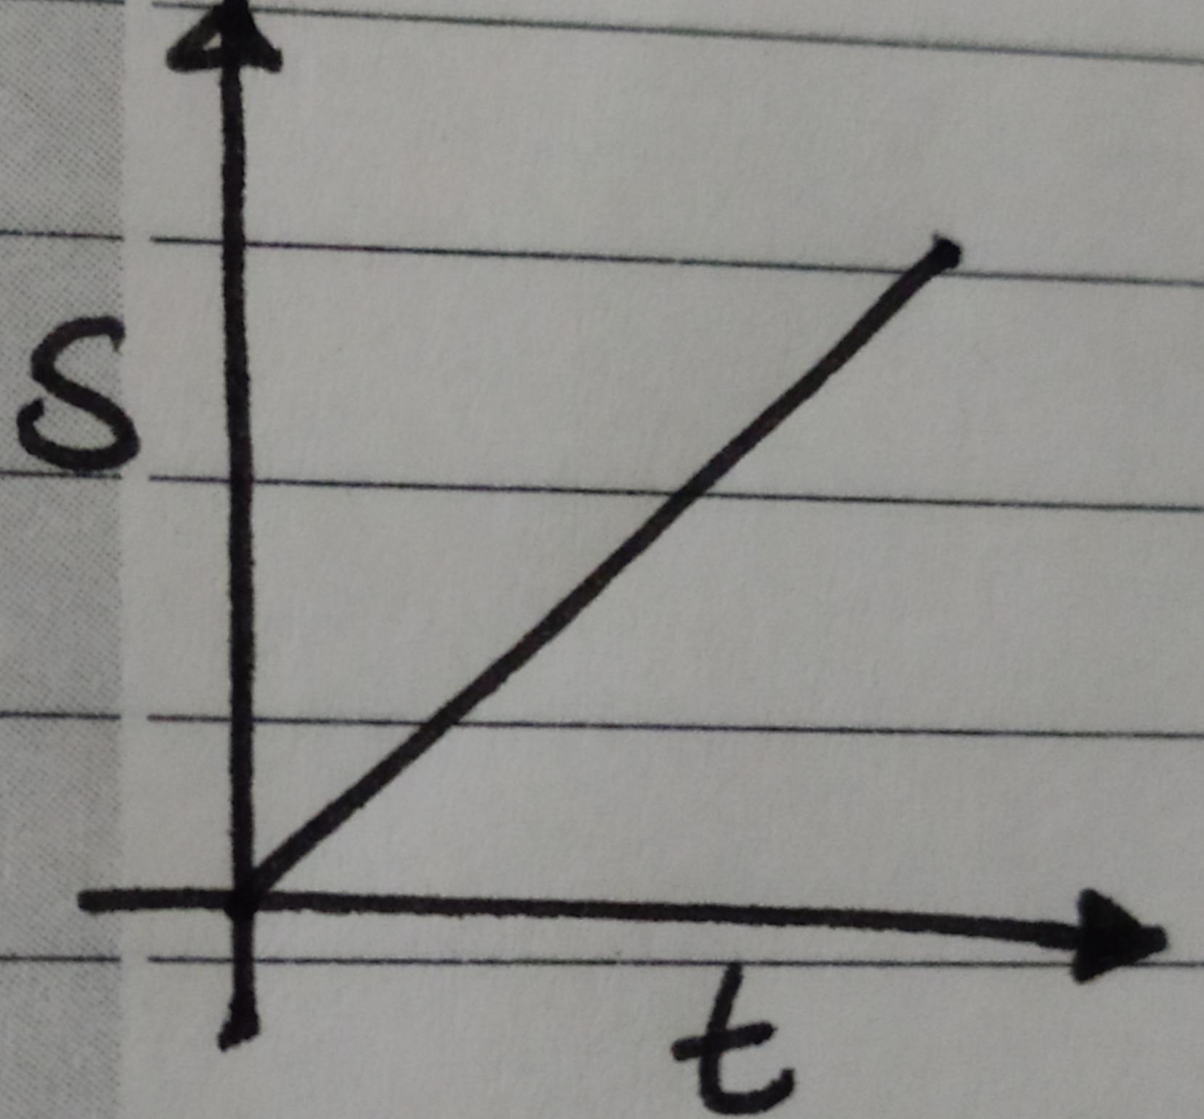

(a). Uniform acceleration

(b). Zero acceleration

(c). Increasing velocity

(d). None of the above

14.What does this graph represent:

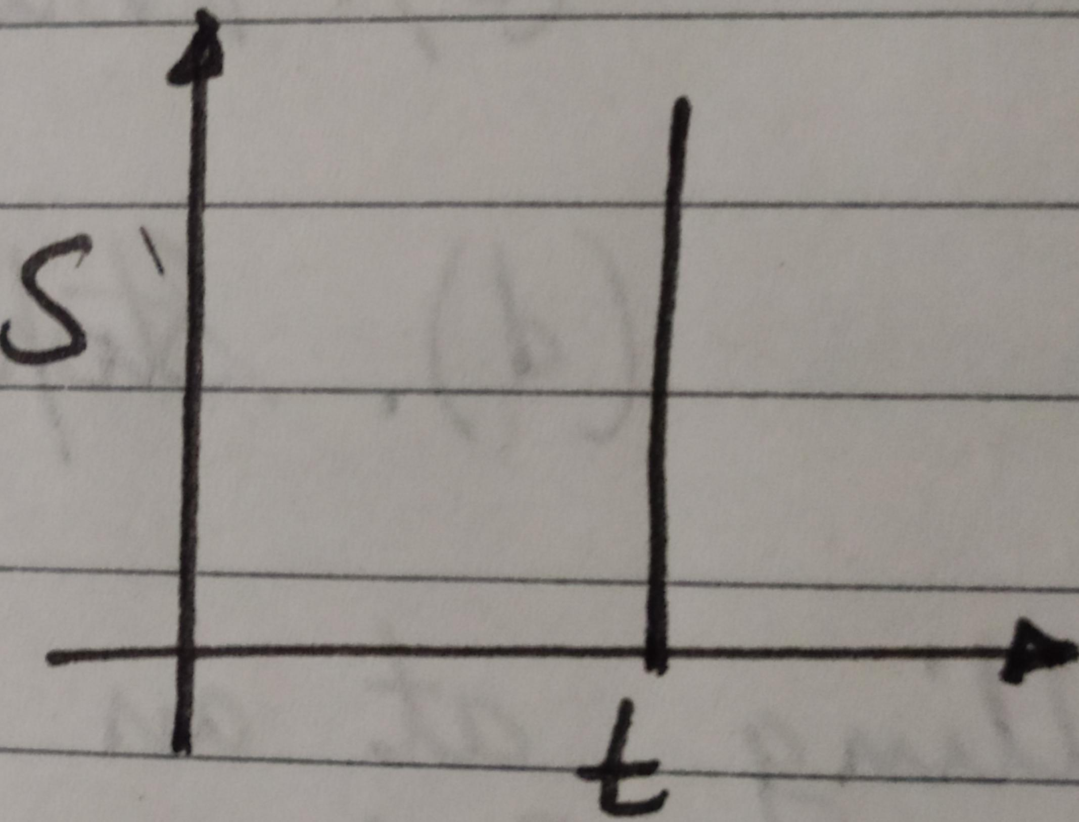

(a). Time is constant

(b). Object is at infinite distance

(c). Both of the above

(d). None of the above

15.In a X-Y plot, the dependent variable is represented by:

(a). x-axis

(b). y-axis

(c). Both (a) and (b)

(d). None of these

16.A car is travelling at a speed of 85 km/hr. How long will it take to complete a journey of 450 km with just a 20 minute break in between?

(a). 5.29 hrs

(b). 5.6275 hrs

(c). 5.3 hrs

(d). None of the above

17.A car started from rest and accelerated to a uniform velocity of 60 kmph for 3 minutes. However, it encountered a traffic on the way and slowed down to 30 kmph, which it maintained for 5 min. As the traffic cleared, the car took 10 min to reach the destination at a speed of 45 kmph. What is the total distance covered by the car?

(a). 40.5 km

(b). 13 km

(c). 11.25 km

(d). None of the above

**Basic Maths:**

1.A group of friends planned to organize a birthday party for which they had to buy candles, balloons, decorative lights and a chocolate cake. Sonu bought 10 balloons for Rs.3 each, Tina bought 8 mini-candles for Rs.5 each, Pinky spent Rs.650 on cake and Rinku spent Rs.99 for decorative lights. How much money did they spend altogether?

(a). Rs.757/-

(b). Rs.787/-

(c). Rs.819/-

(d). Rs.799/-

2.In a food stall, Rahul sold 5 plates of Panipuris in the first hour, and for each hour after that, he sold 8 plates of Panipuris. He ran the food stall for 5 hours. If each plate contained 6 puris, how many Panipuris did he sell in all?

(a). 222

(b). 270

(c). 390

(d). 240

3.Raju has 15 apples,30 oranges and 18 strawberries. He sells them to Manju, who had 3 oranges,5 apples and 2 strawberries remaining from previous purchase. How many apples, oranges and strawberries does Manju have with him?

(a). 18 apples,35 oranges and 20 strawberries

(b). 20 apples,21 oranges and 32 strawberries

(c). 17 apples,33 oranges and 21 strawberries

(d). 20 apples,33 oranges and 20 strawberries

4.There are 20 players in a cricket team, of which only 11 get to play in a match. So,9 players did not get to play.True/False?

5.Annu has a box of 30 sweets, which needs to be distributed equally among 24 colleagues at office. How much does each colleague get?

(a). 0.8th of a sweet

(b). 1th of a sweet

(c). th of a sweet

(d). None of the above

6.For a board exam,2 students are to be seated per bench. There are 30 benches per classroom. The number of students appearing for the exam are 3960.How many benches are required? How many classrooms need to be arranged?

(a). 1980,66

(b). 1986,132

(c). 3960,33

(d). None of the above

7.Lucky has a collection of 136 marbles. He plans to distribute it among his 8 friends. How many does each one get?

(a). 16

(b). 17

(c). 18

(d). 19